

WRAP RECIPES!


Breakfast
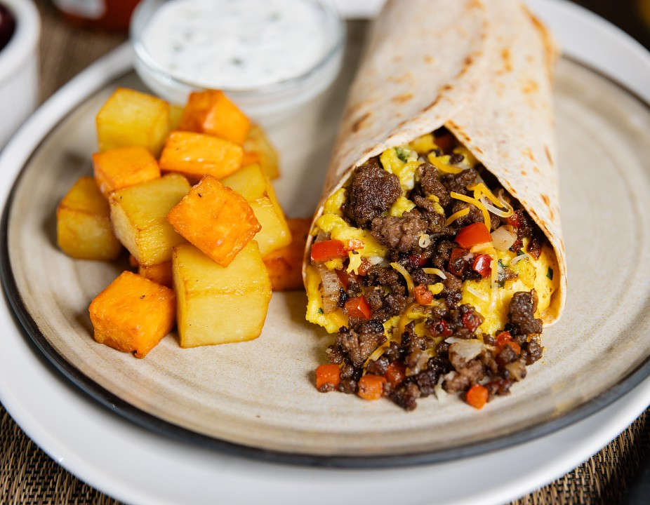

BEEF BREAKFAST BURRITOS
Ground Beef, peppers and onions are quickly sautéed and wrapped up with scrambled eggs. Serve with lime-cilantro cream and salsa.
30 MIN 4 SERVINGS 430 CAL 38 G PROTEIN

INGREDIENTS:
12 ounces Ground Beef (93% lean or leaner) 1 medium red bell pepper, chopped
1 small onion, finely chopped
2 teaspoons ground ancho chile powder 1/2 teaspoon ground cumin
4 eggs, beaten
2 tablespoons water
1 tablespoon finely chopped fresh cilantro 1/4 teaspoon salt (optional)
1/3 cup reduced-fat shredded Mexican cheese blend or shredded Cheddar cheese 4 medium spinach or plain flour tortillas (10-inch diameter), warmed
Salsa (optional)
Lime-Cilantro Cream:
1/2 cup reduced-fat dairy sour cream 1 tablespoon fresh lime juice
1 tablespoon finely chopped fresh cilantro

COOKING:
1. Combine Lime-Cilantro Cream ingredients in small bowl, if desired. Cover and refrigerate until ready to use.

. Heat large nonstick skillet over medium heat until hot. Add Ground Beef with bell pepper, onion, chile powder and cumin; cook 8 to 10 minutes, breaking into small crumbles and stirring occasionally. Pour off drippings, as necessary. Remove from beef mixture from skillet; keep warm.
Cook's Tip:
Cooking times are for fresh or thoroughly thawed ground beef. Ground beef should be cooked to an internal temperature of 160ºF. Color is not a reliable indicator of ground beef doneness.
3. Combine eggs, water and 1 tablespoon cilantro in medium bowl. Spray same skillet with cooking spray. Pour into skillet; cook over medium heat 2 to 3 minutes or until scrambled, stirring occasionally. Season with salt, if desired. Stir in beef mixture and cheese; cook 1 minute or until heated through, stirring occasionally.
Cook's Tip: You may substitute 1 cup egg substitute for beaten eggs. Omit water. Continue as directed in step 3.
4. Spoon beef mixture evenly in a row across center of each tortilla, leaving 1-inch border on right and left sides. Fold right and left sides of tortilla over filling. Fold bottom edge up over filling and roll up; cut diagonally in half. Serve with Lime-Cilantro Cream and salsa, as desired.
TEST KITCHEN TIPS

Use a potato masher to break up Ground Beef into small crumbles while browning.

Wash hands with soap and water before cooking and always after touching raw meat. Separate raw meat from other foods.
Wash all cutting boards, utensils, and dishes after touching raw meat.
Do not reuse marinades used on raw foods. Wash all produce prior to use.
Cook steaks and roasts until temperature reaches 145°F for medium rare, as measured by a meat thermometer, allowing to rest for three minutes. Cook Ground Beef to 160°F as measured by a meat thermometer.
Refrigerate leftovers promptly.
For more information on degree of doneness and other cooking tips visit: https://www.beefitswhatsfordinner.com/cooking/determining-doneness For more information on safe food handling and beef safety, see: https://www.beefitswhatsfordinner.com/cooking/food-safety
93% LEAN
80% LEAN

428 CALORIES 9g SAT FAT 38g PROTEIN 5.3 mg IRON 7.9 mg ZINC

* Based on a 2,000 calorie diet
** Percent Daily Values are based on a 2,000-calorie diet

Nutrition information per serving using 93% lean ground beef: 428 Calories; 187.2 Calories from fat; 20.8g Total Fat (9 g Saturated Fat; 0.1 g Trans Fat; 2.3 g Polyunsaturated Fat; 7.1 g Monounsaturated Fat;) 287 mg Cholesterol; 460 mg Sodium; 22 g Total Carbohydrate; 2.6 g Dietary Fiber; 3.4 g Total Sugars; 38 g Protein; 0 g Added Sugars; 221 mg Calcium; 5.3 mg Iron; 678 mg Potassium; 1.1 mcg Vitamin D; 0.7 mg Riboflavin; 8.9 mg NE Niacin; 0.7 mg Vitamin B₆; 3.5 mcg Vitamin B₁₂; 477 mg Phosphorus; 7.9 mg Zinc; 45.1 mcg Selenium; 253.1 mg Choline.

This recipe is an excellent source of Protein, Iron, Riboflavin, Niacin, Vitamin B6, Vitamin B12, Phosphorus, Zinc, Selenium, and Choline; and a good source of Calcium, and Potassium.

Lunch
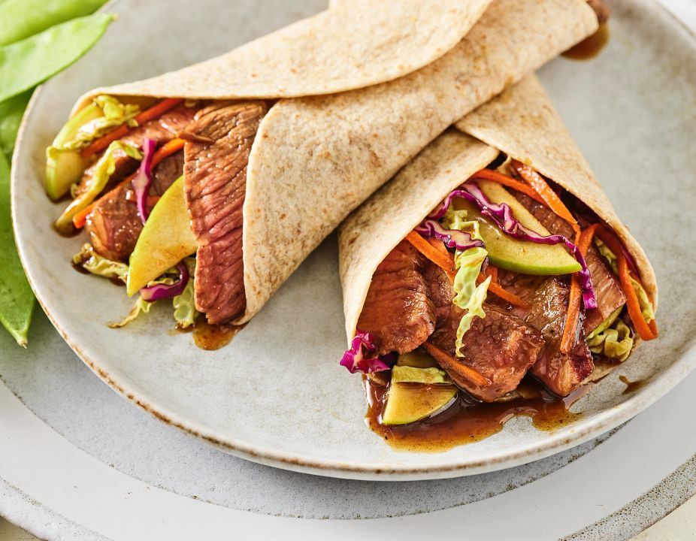

MU SHU STEAK & APPLE WRAPS
Hand-held and perfectly portable, these wraps are great on the go.
30 MIN 4 SERVINGS 480 CAL 32 G PROTEIN

INGREDIENTS:
4 beef Tri-Tip Steaks, cut 1 inch thick (about 4 ounces each) 3/4 teaspoon ground cinnamon
1/4 teaspoon pepper 1/4 cup hoisin sauce 1 tablespoon honey Salt (optional)
3 cups tri-color coleslaw mix (with green cabbage, red cabbage and carrots) 1 Granny Smith apple, peeled and thinly sliced
8 medium whole wheat flour tortillas (8 to 10-inch diameter), warmed

COOKING:
- Combine cinnamon and pepper; press evenly onto beef steaks. Heat large nonstick skillet over medium heat until hot. Place steaks in skillet; cook 9 to 12 minutes or until beef reaches an internal temperature for medium rare (145°F) to medium doneness (160°F) as measured by a meat thermometer, turning occasionally.
- Combine hoisin sauce and honey in large bowl. Carve steaks into thin slices; season with salt, if desired. Add steak slices, coleslaw mix and apple to hoisin mixture; toss to coat.
- Place equal amounts of beef mixture down center of each tortilla, leaving 1-1/2-inch border on right and left sides. Fold bottom edge up over filling. Fold right and left sides to center, overlapping edges; secure with wooden picks, if necessary.

Wash hands with soap and water before cooking and always after touching raw meat. Separate raw meat from other foods.
Wash all cutting boards, utensils, and dishes after touching raw meat.
Do not reuse marinades used on raw foods. Wash all produce prior to use.
Cook steaks and roasts until temperature reaches 145°F for medium rare, as measured by a meat thermometer, allowing to rest for three minutes. Cook Ground Beef to 160°F as measured by a meat thermometer.
Refrigerate leftovers promptly.
For more information on degree of doneness and other cooking tips visit: https://www.beefitswhatsfordinner.com/cooking/determining-doneness For more information on safe food handling and beef safety, see: https://www.beefitswhatsfordinner.com/cooking/food-safety

484 CALORIES 5g SAT FAT 32g PROTEIN 1.8 mg IRON 4.3 mg ZINC

* Based on a 2,000 calorie diet
** Percent Daily Values are based on a 2,000-calorie diet

Nutrition information per serving: 484 Calories; 117 Calories from fat; 13g Total Fat (5 g Saturated Fat; 4 g Monounsaturated Fat;) 67 mg Cholesterol; 958 mg Sodium; 61 g Total Carbohydrate; 8.8 g Dietary Fiber; 32 g Protein; 1.8 mg Iron; 6.8 mg NE Niacin; 0.5 mg Vitamin B₆; 1.9 mcg Vitamin B₁₂; 4.3 mg Zinc; 26.6 mcg Selenium; 90.1 mg Choline.
This recipe is an excellent source of Dietary Fiber, Protein, Niacin, Vitamin B6, Vitamin B12, Zinc, and Selenium; and a good source of Iron, and Choline.

Dinner
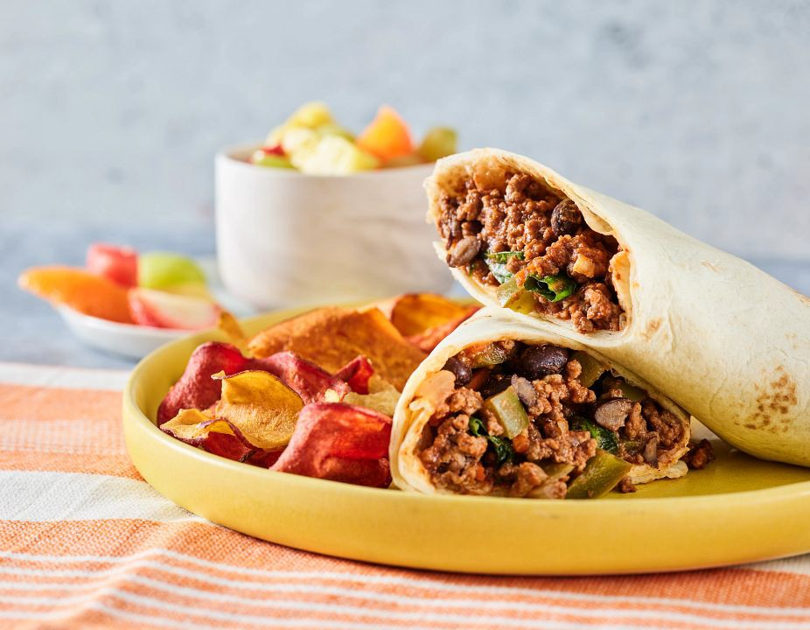

SAUCY BEEF WRAPS
Reminiscent of a childhood sloppy sandwich, this Ground Beef wrap gets a dose of goodness from a homemade sauce and lots of veggies!
35 MIN 4 SERVINGS 400 CAL 31 G PROTEIN

INGREDIENTS:
1 pound Ground Beef (93% lean or leaner) 1/3 cup chopped onion
1/4 cup chopped green bell pepper 1 to 2 cloves garlic, minced
3/4 cup water
1/3 cup tomato paste
2 tablespoons packed brown sugar 1 tablespoon white vinegar
1/2 teaspoon chili powder
1/4 teaspoon salt
1 cup fresh baby spinach
1/3 cup canned black beans, rinsed, drained 1/4 cup shredded carrots
4 medium flour tortillas (8 to 9-inch diameter), warmed

COOKING:
- Brown Ground Beef with onion, bell pepper and garlic in large nonstick skillet over medium heat 8 to 10 minutes, breaking beef up into 1/2-inch crumbles. Pour off drippings, if necessary.
Cook's Tip: Cooking times are for fresh or thoroughly thawed Ground Beef. Ground Beef should be cooked to an internal temperature of 160ºF. Color is not a reliable indicator of Ground Beef doneness.
- Stir in water, tomato paste, brown sugar, vinegar, chili powder and salt; bring to a boil. Reduce heat; simmer 5 minutes or until slightly thickened. Add spinach, beans and carrots; continue simmering 3 to 4 minutes or until heated through.
. Spoon filling evenly in a row across center of each tortilla, leaving 1-1/2-inch border on right and left sides. Fold right and left sides of tortilla over filling. Fold bottom edge up over filling and roll up.

Wash hands with soap and water before cooking and always after touching raw meat. Separate raw meat from other foods.
Wash all cutting boards, utensils, and dishes after touching raw meat. Do not reuse marinades used on raw foods.
Wash all produce prior to use.
Cook steaks and roasts until temperature reaches 145°F for medium rare, as measured by a meat thermometer, allowing to rest for three minutes. Cook Ground Beef to 160°F as measured by a meat thermometer.
Refrigerate leftovers promptly.
For more information on degree of doneness and other cooking tips visit: https://www.beefitswhatsfordinner.com/cooking/determining-doneness For more information on safe food handling and beef safety, see: https://www.beefitswhatsfordinner.com/cooking/food-safety
93% LEAN
401 CALORIES 5g SAT FAT 31g PROTEIN 4.1 mg IRON 6 mg ZINC

* Based on a 2,000 calorie diet
** Percent Daily Values are based on a 2,000-calorie diet

Nutrition information per serving, using 93% lean ground beef: 401 Calories; 108 Calories from fat; 12g Total Fat (5 g Saturated Fat; 3 g Monounsaturated Fat;) 76 mg Cholesterol; 797 mg Sodium; 43 g Total Carbohydrate; 4.4 g Dietary Fiber; 31 g Protein; 4.1 mg Iron; 6.3 mg NE Niacin; 0.4 mg Vitamin B₆; 2.3 mcg Vitamin B₁₂; 6 mg Zinc; 18.4 mcg Selenium; 81.3 mg Choline.

This recipe is an excellent source of Protein, Iron, Niacin, Vitamin B6, Vitamin B12, Zinc, and Selenium; and a good source of Dietary Fiber, and Choline.

